**Purpose:** In this experiment you will be measuring the thrust generated by a water bottle rocket containing 1 liter of water and pressurized to 40 psi. You will accomplish this by using a static test stand developed for this experiment. A load cell collects force output data as you release a stopper allowing your rocket to generate thrust. The thrust data allows you to calculate Specific Impulse (Isp) needed for your MATLAB trajectory model. **To ensure your safety, protective glasses are required for all participants in the test stand area.**

**Equipment List:**

* 12.5 Liter Compressed Air tank.
* Safety Glasses
* Test stand
* Lab station 34A (south side of ITLL 2B)
* Air tank regulator
* Pressure regulator
* Pressure release mechanism
* Sink
* Funnel
* Liquid Soap
* Crescent wrench

**Set up Procedure:**

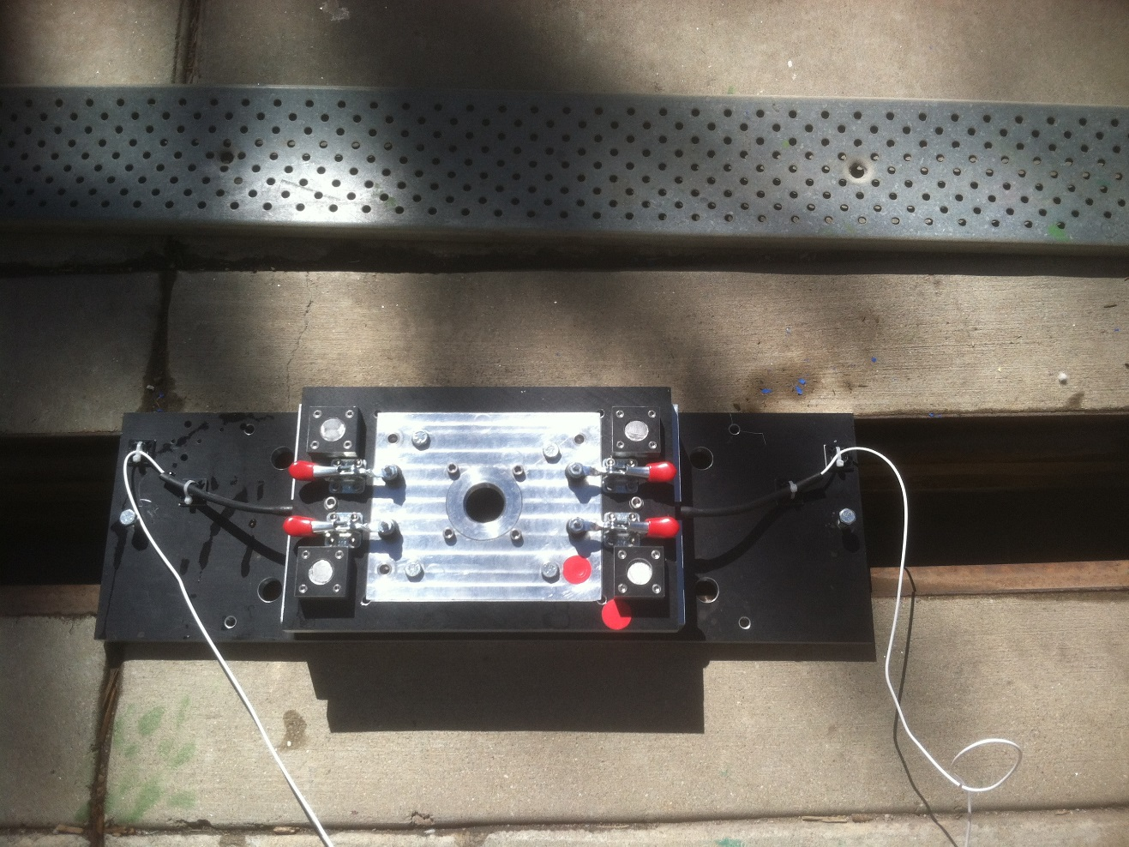

**You will be working with high pressure air and water and quick release mechanisms; you MUST wear your safety glasses at all times!**

1. Pressurize yellow air tank to approximately 90 psi. This will provide enough air for several tests. Follow this procedure:
   1. Connect air hose to roof mounted hoses in ITLL using the converter. This is often left attached to the hose near the Checkout office.
   2. Using air connector valve, fill air tank via the small valve under the red tank fill valve. Fill tank until the pressure gauge reads ~80 psi.
   3. Disconnect fill hose by turning the brass ring to OFF and release the quick connect fitting by pulling the mechanism away from attached hose.
2. Configure test stand as shown in the figure above. Remove the metal plate from the gutter and attach the test stand to the gutter using the bolts on the sides of the test stand.
3. Verify the empty bottle weight and fill water bottle rocket with 1 kg of water (corresponds to 1 liter).
   1. Fill the bottle half full, and then use the scale and a 10ml beaker to add water until the total weight is within 0.5g of the target weight.
4. To regulate the pressure of your rocket, the regulator on the end of the orange hose which extends out of the air tank, should already be set to 40 psi.
   1. Close exit control valve (located after the regulator.) NOTE: Perpendicular is closed, in line is open.
   2. On air tank, open the tank control valve.
   3. Verify regulator reads 40 psi +/- 1 psi. If not, adjust the black knob to set pressure.
   4. If you reduce the regulator setting, vent slightly the exit control valve to release residual pressure and reclose to get an accurate pressure reading.
   5. Close air tank control valve.



1. Ensure load cell wires are run through window on ITLL South side and connected as described in the document ASEN2004_Static_test_USB_VI_procedure. When all data transfer connections have been made, open and run the VI.
2. Install Rocket on test stand as shown in the figures above as follows:
   1. Raise the stops holding the center plate to the test stand using the red levers. Remove the center plate from the test stand. The test stand should look as shown in the figure below.

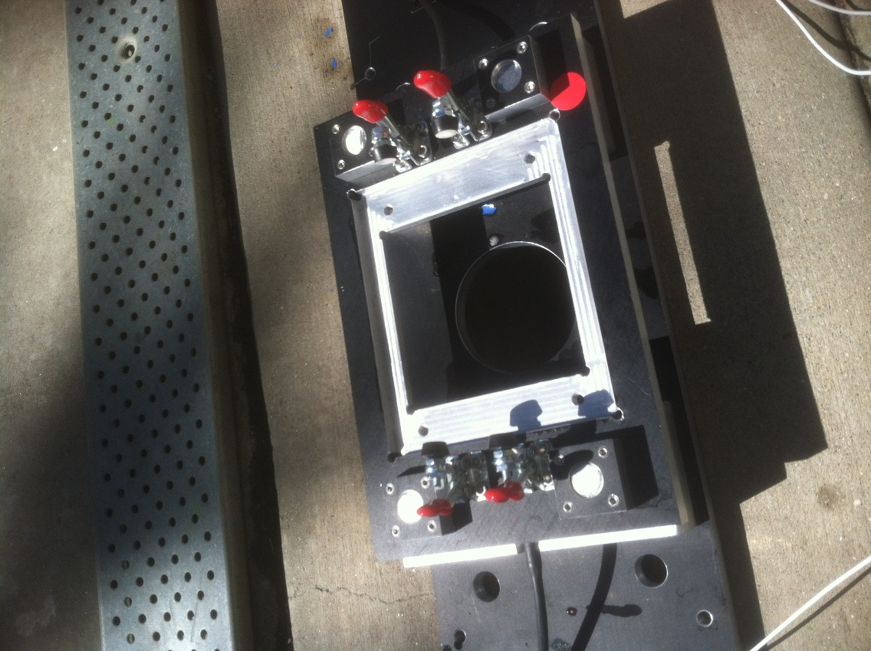

* 1. Screw the center plate onto the threaded neck of the bottle.
  2. Place the release mechanism between the upper and lower surfaces of the test stand. Thread the stopper from the side of the test stand, under the entire test stand, and up through the round hole in the bottom.

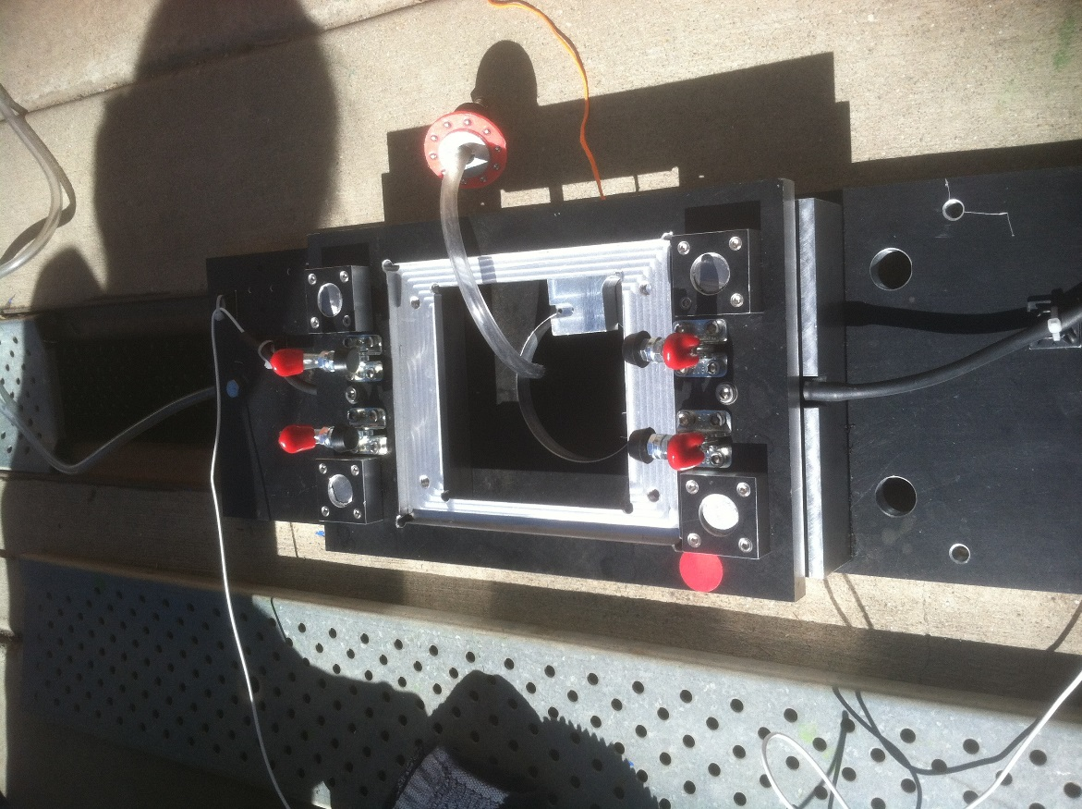

* 1. Coat stopper with soap to ensure a secure, low friction seal.
  2. Insert the stopper into the mouth of the bottle.

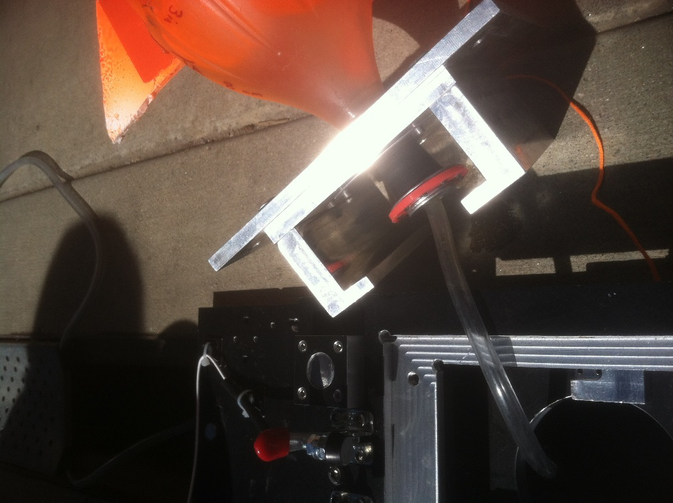

* 1. Put the release bracket between the bottom of the stopper ring and the ledge on the test stand plate.

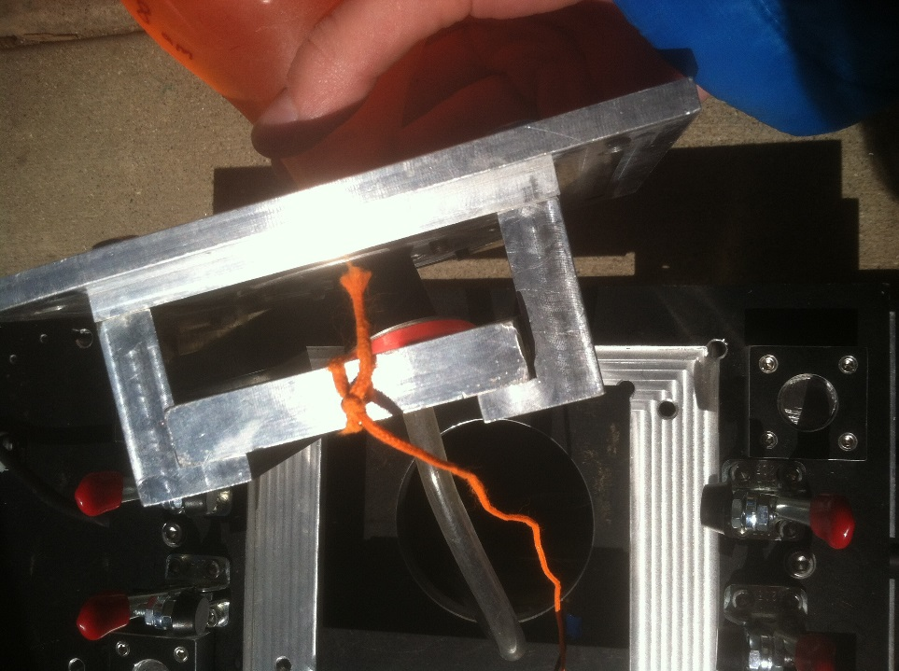

Push this bracket securely into place so that the bracket is flush with the pressurization tube.

* 1. Turn the bottle upright and insert the plate back into the test stand. Make sure the red dots on the test stand body and test stand plate are in the same corner. In the picture below, the red dots are in the upper right corner.

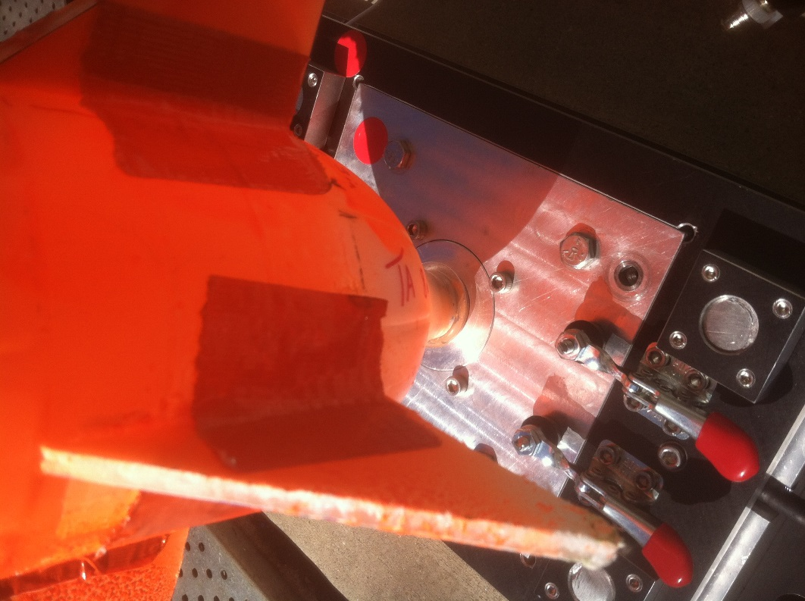

* 1. Secure the plate to the test stand by lowering the stops using the red levers. Press on the handles to ensure all four click into place.

1. Check to make sure the release string and clear plastic pressurization tube are free of interference.
2. Connect clear pressurization tube to air tank outlet tube via the quick connector located on the pressure regulator.
3. Open air control valve on tank to pressurize rocket, carefully monitor the regulator pressure gauge to ensure that the pressure does not exceed 40 psi.

********************************************************************

NOTE

The pressure inside the rocket should be 40 psi plus or minus 1 psi. Since there is no way to remove the pressure from the rocket without firing, the test will be deemed invalid, and will need to be repeated.

********************************************************************

1. Wait until no more significant ‘bubbling’ visible inside the rocket and then turn off the air tank valve.
2. Disconnect the air regulator at the quick connect and remove from the launch area to avoid getting the regulator wet.

********************************************************************

NOTE

Test team will pull release mechanism from a minimum of 8ft away.

Ensure **safety glasses** are worn by everyone in the test area.

********************************************************************

1. Verify LabVIEW VI Data Acquisition System is ready before proceeding.
2. Test Controller polls all team members for ‘go/ no go’ readiness.
   1. VI running?
   2. Propellant pressurized?
   3. Safety glasses on?
3. Begin countdown. Have the VI operator click the ‘Enable Data Capture?’ button around T=2 seconds in the countdown.
4. At T=0, pull the release cord as horizontal as possible with smooth quick motion.
5. The VI will automatically terminate data recording after the test.

********************************************************************

NOTE

Handover test stand to next team, or if this was the last test for the day, disassemble test stand, replace gutter plate into gutter, disconnect data cables, power down VI, stow gear.

You must clean up the test area before leaving.

********************************************************************